Meeting Minutes

Metropolitan Utility Coordinating Council
MUCC, C/O Jarrod Morrison, 3700 SE 17th Ave, Portland, OR 97202

September 22, 2010
Our next meeting will be September 29th, 2010
at Washington County offices at 1400 SW Walnut St, Hillsboro OR
with a presentation from several local Locating Companies.

ATTENDEES: See attached listing.
__________________________________________________________________________________________________

REPORTS:

Treasurer’s Report for May 2010: One transaction this past month – the YUCC sponsorship.

M Bank Golf Fund Golf Fund Rodeo Visa
(Checking) (Savings)
Beginning Balance $ 4,424.15 $ 1,121.81 $ 5.00 $ 0.00 $ -
Ending Balance $ 4,124.15 $ 1,121.81 $ 5.00 $ 0.00 $ -

Payments / Purchases / Income:
Dues are still trickling in - please see the updated list near the end of the minutes to see if your company has paid its dues. Send your dues to Jarrod Morrison at the address above.
As a non-profit organization, all monies collected go for supplies/events to educate the public!
Our ending balance (all accounts) must be under $5,000 at the end of the year or we will have to pay taxes.

Damage Report: See the end of the minutes.
The Common Ground Alliance (CGA) encourages the use of their Damage Information Reporting Tool (DIRT). You can check this out at www.cga-dirt.com

P&E Report (Publicity and Education):

P&E General: Send your ideas to Don Patterson (dwp@nwnatural.com) and Anita Floyd (anita.floyd@qwest.com)
New: The OUNC ticket count is down.
April 2011 should be next year’s Dig Safe Month. Don will work on getting multiple UCC’s to get together and do some radio ads and maybe some printed ads for that month.
December 2nd, 2010 is Landscape Day at the Convention Center. OUNC will have a booth there. The need help to talk to landscapers
We should support the OUNC at the GOSH Conference March 7-10, 2011, by volunteering at the event. The OUNC will have a booth there and will be giving a 90 minute presentation.
The OUNC has put together a Locators Training class. It will be at the Clackamas Community College-Wilsonville Campus on Monday & Tuesday, November 1st and 2nd. Follow this link for details: http://www.digsafelyoregon.com/locator-training-2010.asp The class is full at this time.
Don Patterson did a radio show in Hood River last month and has gotten lots of feedback from it.
Qwest will become part of Century Link early next year. Their coverage will expand into 37 states.
The Joint States meeting was in mid-September. Only 51 people were in attendance.
Old:
Columbia Gorge/Hood River areas are planning radio ads to promote 811 as well as using small newspaper ads. Don Patterson has checked into our local area and found that there is one radio company that owns about a dozen smaller newspapers in the local region. We can run a single ad (3.5” x 4” in color) in these local papers for just $145/month. Don Patterson will put together a proposal for our information and vote for the next MUCC meeting. We are thinking of doing several months of advertising this summer/fall and perhaps 6 months of advertising next year.
OUNC is looking for new promotional items.
Requests for cards/pens/hats/other items are being downsized because OUNC doesn’t want to run out of inventory. Please only order what you really need.

811 CAMPAIGN: (No new information this month)
Home Depot is breaking out in the western region. Go into your local Home Depot and if you do not see the 811 info, ask at the Contractors desk.
In Oregon, the stores will carry Key Chains for all equipment and color code cards. The “Associates” who will be trained to answer questions will have patches on their aprons.
The OUNC meets the 2nd Wednesday of the month at the One Call Center in Portland.
You may go to www.call811.com website for more information.
____________________________________________________________________________________________________________

Upcoming Events / Meetings:

Locators Presentation/MUCC Meeting – October 29th, 2010 (Friday) This presentation/meeting will be held at the Washington County offices. Please see the attached flyer for details.

2010 Utility Locator Training – November 1 & 2, 2010 (Monday/Tuesday) This class is full. http://www.digsafelyoregon.com

2010 Landscape Expo – December 2nd, 2010 www.oregonlandscape.org This is a Landscapers Conference. OUNC will have their booth there.

2011 Locate Training – Lane County February 17th, 2011 Lane County will be hosting a class for locators through Staking University. They are looking to hold it in February 2011. It will be a one day class for approximately 75 people. The instructor will be from Staking University. Details will be available soon.

Garden Shows
2011 SPRING YARD, GARDEN & PATIO SHOW – February 18 – 20 (Friday through Sunday): Time to discuss if we want to have a booth at the next show.
2011 SPRING HOME AND GARDEN SHOW – February 23 – 27 (Wednesday through Sunday): Time to discuss if we want to have a booth at the next show.

2011 Governor’s Occupational Safety & Health Conference - GOSH – March 7-10, 2011 www.oregongosh.org OUNC will have their booth there.

2011 LOCATE RODEO: There will not be a Locate Rodeo in 2010. This will be a biennial event.

REGIONAL LAW UPDATE: The Coos Bay event has been postponed (indefinitely). There was a roadblock trying to get the lists of people for attendees. Updates to follow as they come in.

_______________________________________________________________________________________

OLD BUSINESS:

RAA - Next meeting – October 22nd, 2010, 8:00
Hearings are at the PUC Building at 550 Capitol St NE, Salem. Be sure to bring change for the parking meters if you attend. The OUNC has asked Michael Thompson to put together a summary of the RAA hearings. This would benefit the local councils to help promote education to the local contractors in the areas where infractions are the highest.
Locating Inc is suggesting that the letters “UL” be placed along the curb/edge of roadway for any Un-locatable Lines.

811 Locate Requesting is available 24/7/365! Don’t wait until first thing Monday morning to call in your locates – you’ll find the lines are packed with everyone else calling at the same time! Call Saturday or Sunday if you want to get your request in early. Still expect two (2) business days for the locates to show up!
Should you encounter an un-located utility while excavating – stop digging, call 811 to report it immediately, determine that there is no immediate danger, and you can continue working (if your project allows) using extreme care in the affected area. See Page 23 (5) in the Standards Manual.

NEW BUSINESS:
The Nominating Committee (Ralph Reisbeck of PGE and Troy Klein of NW Natural) have been contacting people to serve on next years MUCC Board. They have interest from several people, and voting will take place in November. Please consider taking a position or letting us know if you know of someone who has the time to commit to our cause. These are worthwhile positions that give you great contacts to other businesses and groups. The positions available are Secretary, Vice President / Treasurer and President. You can contact them at ralph.reisbeck@pgn.com and/or tak@nwnatural.com with your nomination.
REMINDER…Send your current and/or upcoming projects to Dawn at dhaase@co.clackamas.or.us and they will be attached to the Minutes e-mail so everyone will know where projects are or will be happening and your company can schedule accordingly.
______________________________________________________________________________________

Remember – CCC – Communicate, Coordinate, Cooperate!
______________________________________________________________________________________________________________________________________________

VOLUNTEERS: As you have read, there are a variety of opportunities for all to volunteer and help spread the word of our Call before You Dig message. These are great opportunities to network and get to know each other better. Take advantage of these opportunities and make new friends. If you are able, make yourself available to be on a committee or to volunteer on any of the upcoming projects and events these next couple of years. This is what this Council is all about and how we strive to be excellent!
_______________________________________________________________________________________
Oregon Utility Notification Center  www.digsafelyoregon.com | Oregon Utility Coordinating Council  www.oucc.net

Check out the websites for info on the Oregon Dig Law, upcoming events and on your local Council(s).
There are new changes to the website – check them out.
Also available: see information on Best Practices at www.commongroundalliance.com
_______________________________________________________________________________________

Respectfully submitted by Dawn Haase.
_______________________________________________________________________________________
The next meeting: Date: Friday, October 29th, 2010 7:30 – 10:30
Location: Washington County, 1400 SW Walnut St, Hillsboro

The 2010 schedule is the 4th Wednesday of each month except November

(the week before Thanksgiving this year) and December (no meeting).

January 27th February 24th March 24th April 28th
May 26th June 23rd July 28th August 25th

September 22nd October 29th November 17th Dec - No meeting

v

NOTE – THE OCTOBER MEETING IS MOVED TO FRIDAY

ACCOMMODATE THE LOCATORS Q & A MEETING. It will be at the

Washington County offices at 1400 SW Walnut St, 2nd floor

The 2011 schedule is the 4th Wednesday of each month except November

(the week before Thanksgiving this year) and December (no meeting).

January 26th February 23rd March 23rd April 27th
May 25th June 22nd July 27th August 24th

September 28th October 26th November 16th Dec - No meeting
______________________________________________________________________________________

2010 MUCC Executive Board
MUCC, C/O Jarrod Morrison, 3700 SE 17th Ave, Portland, OR 97202

PRESIDENT: Gary Hyatt, NW Natural, 220 NW 2nd Ave, 3rd Floor, Portland OR 97209

Office - (503) 226-4211 ext 4320, gfh@nwnatural.com

VICE PRESIDENT / TREASURER: Jarrod Morrison, Portland General Electric, 3700 SE

17th Ave, Portland, OR 97202, Office – (503) 736-5505, Cell - (503) 849-7043
Fax - (503) 736-5500, Jarrod.Morrison@pgn.com

SECRETARY: Dawn Haase, Clackamas County DTD Eng, 150 Beavercreek Rd
Oregon City OR 97045, Office – (503) 742-4682, Cell – (503) 789-5728
Fax – (503) 742-4659, dhaase@co.clackamas.or.us

PUBLICITY & EDUCATION: Don Patterson, NW Natural, 220 NW 2nd Ave, 3rd Floor

Portland OR 97209, Office - (503) 226-4211 ext 4387, Cell – (503) 806-0845
Fax – (503) 273-4822, dwp@nwnatural.com

DAMAGE CHAIR: Shannon Davis, Qwest, 100 NW Kearney Ave, Bend, OR 97701

Office – (541) 388-5296, Fax – (541) 388-5269, Shannon.Davis@qwest.com

2010 MUCC PAID MEMBERS

As of 07-28-10
Bones Construction, Inc.  City of Gresham, OPS Center  City of Hillsboro  City of Lake Oswego  City of Milwaukie  City of Oregon City  City of Sandy  City of Tigard  City of Tualatin  Clackamas County  Comcast  Dirt & Aggregate Interchange, Inc | Ditch Witch Northwest  Emery & Sons Construction  Frontier/Verizon  James W Fowler Co.  K&D Services of Oregon, Inc.  Knife River  Lakeside Industries  Locates Down Under  Locating, Inc  Loy Clark Pipeline  Multnomah County  North Sky Communications | Northwest Natural Gas  ODOT  Oldcastle Precast  PacifiCorp / Pacific Power  Portland General Electric  Qwest  Sunrise Water Authority  Superior Fence Construction  Tri-State Construction  Tualatin Valley Water District  Washington County LUT  Williams Pipeline

Damage Report: In 2010 we must have a minimum of three (3) damage reports per month. Please submit your damages within 30 days. The following is from the Website http://oucc.net/ taken October 25, 2010:

July 2010: Eight submittals for damages…
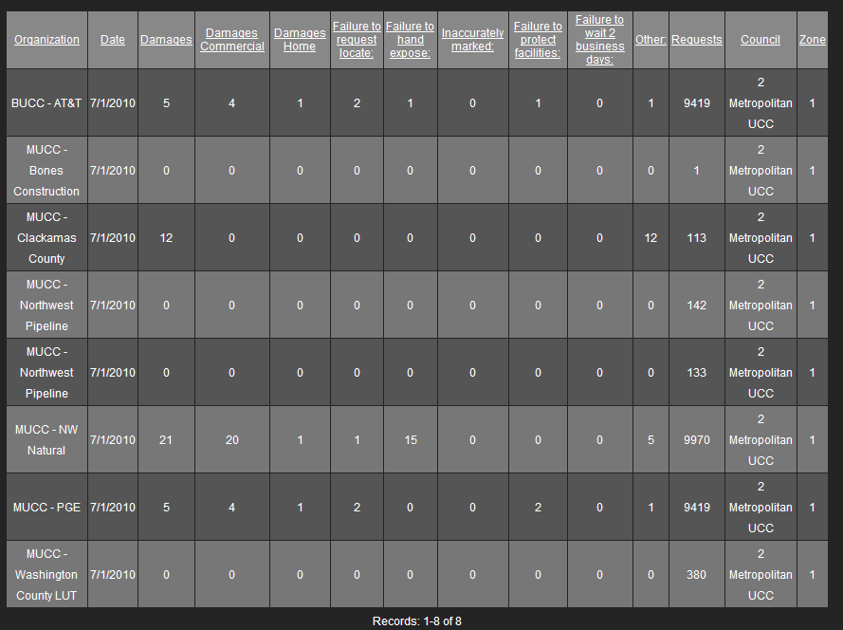

August 2010: Five submittals for damages…

September 2010: Three submittals so far – Don’t forget to report your damages!

