Meeting Minutes

Metropolitan Utility Coordinating Council
MUCC, C/O Jarrod Morrison, 3700 SE 17th Ave, Portland, OR 97202

February 23rd, 2011
Our next meeting will be March 23rd, 2011

ATTENDEES: See attached listing.
__________________________________________________________________________________________________

REPORTS:

Treasurer’s Report for December 2010: 3 Deposits this month (MUCC Dues)

M Bank Golf Fund Golf Fund Rodeo Visa
(Checking) (Savings)
Beginning Balance $ 3,877.65 $ 1,121.81 $ 5.00 $ 0.00 $ -
Ending Balance $ 5,577.65 $ 1,121.81 $ 5.00 $ 0.00 $ -

Payments / Purchases / Income:
There were no checks written in January.
As a non-profit organization, all monies collected go for supplies/events to educate the public!
Our ending balance (all accounts) must be under $5,000 at the end of the year or we will have to pay taxes.

Damage Report: See the end of the minutes.
The Common Ground Alliance (CGA) encourages the use of their Damage Information Reporting Tool (DIRT). You can check this out at www.cga-dirt.com

P&E Report (Publicity and Education):

P&E General: Send your ideas to Don Patterson (dwp@nwnatural.com) and Anita Floyd (anita.floyd@qwest.com)

New: There was not a P&E meeting.

Old:
There is a lot happening these next few months. They are planning to spend about $40,000 next year toward radio advertising.
Home Depot has embraced its partnership with the CGA in this region. The CGA may talk with Lowes and other large stores to promote 811.
The OUNC ticket count is down.
April 2011 should be next year’s Dig Safe Month. Don will work on getting multiple UCC’s to get together and do some radio ads and maybe some printed ads for that month.
We should support the OUNC at the GOSH Conference March 7-10, 2011 at the Convention Center, by volunteering at the event. The OUNC will have a booth there and will be giving a 90 minute presentation. Info on attending can be found at http://oregongosh.com/ . The theme this year is “Safety: It’s a Marathon, Not a Sprint”.
Qwest will become part of Century Link early next year. Their coverage will expand into 37 states.
Columbia Gorge/Hood River areas are planning radio ads to promote 811 as well as using small newspaper ads. Don Patterson has checked into our local area and found that there is one radio company that owns about a dozen smaller newspapers in the local region. We can run a single ad (3.5” x 4” in color) in these local papers for just $145/month. Don Patterson will put together a proposal for our information and vote for the next MUCC meeting. We are thinking of doing several months of advertising this summer/fall and perhaps 6 months of advertising next year.
OUNC is looking for new promotional items.
Requests for cards/pens/hats/other items are being downsized because OUNC doesn’t want to run out of inventory. Please only order what you really need.

811 CAMPAIGN: (No new information this month)
Home Depot is breaking out in the western region. Go into your local Home Depot and if you do not see the 811 info, ask at the Contractors desk.
In Oregon, the stores will carry Key Chains for all equipment and color code cards. The “Associates” who will be trained to answer questions will have patches on their aprons.
The OUNC meets the 2nd Wednesday of the month at the One Call Center in Portland.
You may go to www.call811.com website for more information.
____________________________________________________________________________________________________________

Upcoming Events / Meetings:
UTILITY LOCATOR TRAINING SEMINAR: April 20 – 21, 2011 Seaside Civic & Convention Center, 415 First Ave., Seaside, OR 97138, as of 3/9/11 there were still spots available.

2011 LOCATE RODEO: There will not be a Locate Rodeo in 2011. This will be a biennial event. Time to start putting the Committee together!

REGIONAL LAW UPDATE: The Coos Bay event has been postponed (indefinitely). There was a roadblock trying to get the lists of people for attendees. Updates to follow as they come in.

_______________________________________________________________________________________

OLD BUSINESS:

RAA - March 2, 2011 from 9am to 12pm
Hearings are at the PUC Building at 550 Capitol St NE, Salem. Be sure to bring change for the parking meters if you attend. The OUNC has asked Michael Thompson to put together a summary of the RAA hearings. This would benefit the local councils to help promote education to the local contractors in the areas where infractions are the highest.
Locating Inc is suggesting that the letters “UL” be placed along the curb/edge of roadway for any Un-locatable Lines.

811 Locate Requesting is available 24/7/365! Don’t wait until first thing Monday morning to call in your locates – you’ll find the lines are packed with everyone else calling at the same time! Call Saturday or Sunday if you want to get your request in early. Still expect two (2) business days for the locates to show up!
Should you encounter an un-located utility while excavating – stop digging, call 811 to report it immediately, determine that there is no immediate danger, and you can continue working (if your project allows) using extreme care in the affected area. See Page 23 (5) in the Standards Manual.

NEW BUSINESS:

Anita Floyd spoke about the Radio Disney advertising. Don Patterson spoke about getting booths at the street fair community events and possibly partnering with Friends of Trees. Don proposed to budget $1500 to partner with OUNC for 811 radio advertising, we all agreed to proceed.
We are looking into finding different meeting locations throughout the metro area to hold our meetings.
Gary Hyatt asked for prize Give Away’s, if your company has items to donate, please bring them in or let us know how you can help. Also Gary would like for volunteer guest speakers to come in with presentations to our meetings.
So far we we have tentative speakers set up for April ~Williams Pipeline) May ~Cardo TBE and June
~Old Castle Precast (confirmed).

REMINDER…Send your current and/or upcoming projects to Marta Padilla @ marta.padilla@locatinginc.com and they will be attached to the Minutes e-mail so everyone will know where projects are or will be happening and your company can schedule accordingly.

______________________________________________________________________________________

Remember – CCC – Communicate, Coordinate, And Cooperate!
______________________________________________________________________________________________________________________________________________

VOLUNTEERS NEEDED: As you have read, there are a variety of opportunities for all to volunteer and help spread the word of our Call before You Dig message. These are great opportunities to network and get to know each other better. Take advantage of these opportunities and make new friends. If you are able, make yourself available to be on a committee or to volunteer on any of the upcoming projects and events these next couple of years. This is what this Council is all about and how we strive to be excellent!
_______________________________________________________________________________________
Oregon Utility Notification Center  www.digsafelyoregon.com | Oregon Utility Coordinating Council  www.oucc.net

Check out the websites for info on the Oregon Dig Law, upcoming events and on your local Council(s).
There are new changes to the website – check them out.
Also available: see information on Best Practices at www.commongroundalliance.com
_______________________________________________________________________________________

Respectfully submitted by Marta Padilla.
_______________________________________________________________________________________
The next meeting: Date: Wednesday March 23rd 11:30am
Location: Village Inn at 1621 N.E 10th Ave in Portland

The 2011 schedule is the 4th Wednesday of each month except November

(the week before Thanksgiving this year) and December (no meeting).

January 26th February 23rd March 23rd April 27th
May 25th June 22nd July 27th August 24th

September 28th October 26th November 16th Dec - No meeting
______________________________________________________________________________________

2011 MUCC Executive Board
MUCC, C/O Jarrod Morrison, 3700 SE 17th Ave, Portland, OR 97202

PRESIDENT: Gary Hyatt, NW Natural, 220 NW 2nd Ave, 3rd Floor, Portland OR 97209

Office - (503) 226-4211 ext 4320, gfh@nwnatural.com

VICE PRESIDENT / TREASURER: Jarrod Morrison, Portland General Electric, 3700 SE

17th Ave, Portland, OR 97202, Office – (503) 736-5505, Cell - (503) 849-7043
Fax - (503) 736-5500, Jarrod.Morrison@pgn.com

SECRETARY: Marta Padilla, Locating Inc, 6601 NE 78th Ct, Portland OR 97218
Office – (503) 255-4634, marta.padilla@locatinginc.com

PUBLICITY & EDUCATION: Don Patterson, NW Natural, 220 NW 2nd Ave, 3rd Floor

Portland OR 97209, Office - (503) 226-4211 ext 4387, Cell – (503) 806-0845
Fax – (503) 273-4822, dwp@nwnatural.com

DAMAGE CHAIR: Shannon Davis, Qwest, 100 NW Kearney Ave, Bend, OR 97701

Office – (541) 388-5296, Fax – (541) 388-5269, Shannon.Davis@qwest.com

2010 MUCC PAID MEMBERS

As of 02-23-11
Bones Construction, Inc.  BP Olympic Pipeline  City of Gladstone  City of Gresham, OPS Center  City of Hillsboro  City of Lake Oswego  City of Sandy | City of Tualatin  Comcast  Dirt & Aggregate Interchange, Inc  Ditch Witch Northwest  Gonzales Boring & Tunneling  James W Fowler Co.  Linescape | Locating, Inc  ODOT  Old Castle Precast  Port of Portland  Portland General Electric  Sunrise Water Authority  Washington County LUT

Damage Report: In 2011 we must have a minimum of three (3) damage reports per month. Please submit your damages within 30 days. The following is from the Website http://oucc.net/ taken March 15, 2011:

December 2010: Eight submittals for damages…

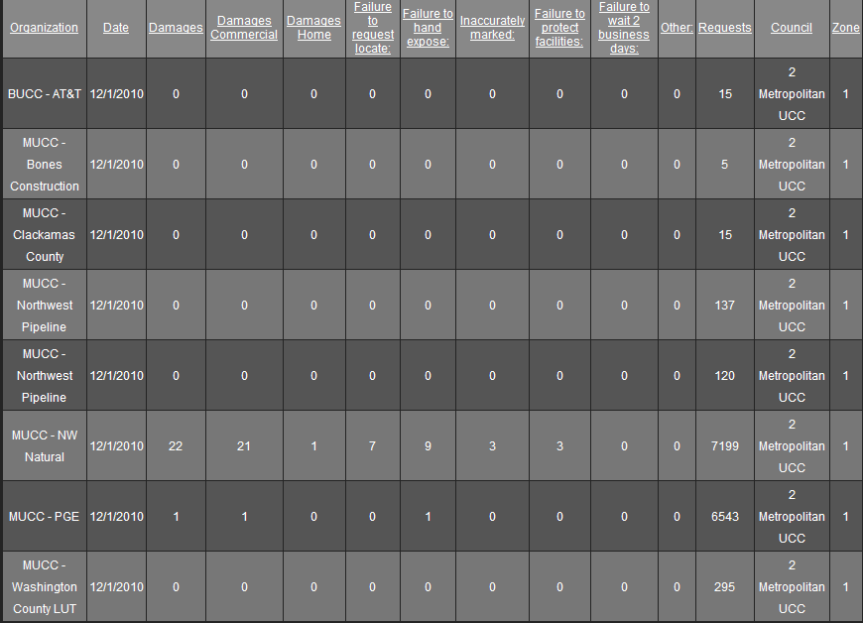

January 2011: Four submittals for damages…
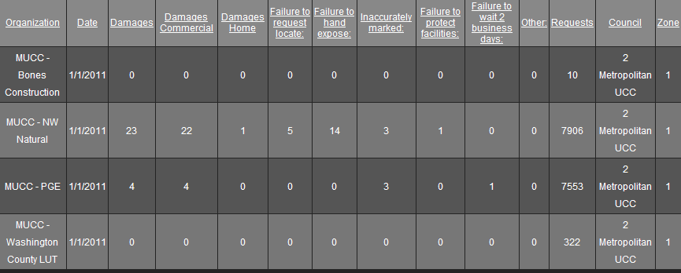

February 2011: Only two submittals so far…Don’t forget to get your reports in!
